**What is statistical tests, and its types?**

**What does a statistical test do?**

Statistical tests work by calculating a [**test statistic**](https://www.scribbr.com/statistics/test-statistic/)– a number that describes how much the relationship between variables in your test differs from the null hypothesis of no relationship.

It then calculates a [***p*-value**](https://www.scribbr.com/statistics/p-value/) (probability value). The *p*-value estimates how likely it is that you would see the difference described by the test statistic if the null hypothesis of no relationship were true.

If the value of the test statistic is more extreme than the statistic calculated from the null hypothesis, then you can infer a **statistically significant relationship** between the predictor and outcome variables.

If the value of the test statistic is less extreme than the one calculated from the null hypothesis, then you can infer **no statistically significant relationship** between the predictor and outcome variables.

**When to perform a statistical test**

You can perform statistical tests on data that have been collected in a statistically valid manner – either through an [experiment](https://www.scribbr.com/frequently-asked-questions/what-is-experimental-design/), or through observations made using [probability sampling methods](https://www.scribbr.com/methodology/probability-sampling/).

For a statistical test to be [valid](https://www.scribbr.com/methodology/internal-vs-external-validity/), your sample size needs to be large enough to approximate the true distribution of the population being studied.

To determine which statistical test to use, you need to know:

* whether your data meets certain assumptions.
* the [types of variables](https://www.scribbr.com/methodology/types-of-variables/) that you’re dealing with.

Statistical tests make some common assumptions about the data they are testing:

1. **Independence of observations** (a.k.a. no autocorrelation): The observations/variables you include in your test are not related (for example, multiple measurements of a single test subject are not independent, while measurements of multiple different test subjects are independent).
2. **Homogeneity of variance**: the [variance](https://www.scribbr.com/statistics/variance/) within each group being compared is similar among all groups. If one group has much more variation than others, it will limit the test’s effectiveness.
3. **Normality of data**: the data follows a [normal distribution](https://www.scribbr.com/statistics/normal-distribution/) (a.k.a. a bell curve). This assumption applies only to [quantitative data](https://www.scribbr.com/methodology/types-of-variables/#quantitative-vs-categorical).

If your data do not meet the assumptions of normality or homogeneity of variance, you may be able to perform a [**nonparametric statistical test**](https://www.scribbr.com/statistics/statistical-tests/#nonparametric), which allows you to make comparisons without any assumptions about the data distribution.

If your data do not meet the assumption of independence of observations, you may be able to use a test that accounts for structure in your data (repeated-measures tests or tests that include blocking variables).

### Types of variables

The [types of variables](https://www.scribbr.com/methodology/types-of-variables/) you have usually determine what type of statistical test you can use.

**Quantitative variables** represent amounts of things (e.g. the number of trees in a forest). Types of quantitative variables include:

* **Continuous** (a.k.a ratio variables): represent measures and can usually be divided into units smaller than one (e.g. 0.75 grams).
* **Discrete** (a.k.a integer variables): represent counts and usually can’t be divided into units smaller than one (e.g. 1 tree).

**Categorical variables** represent groupings of things (e.g. the different tree species in a forest). Types of categorical variables include:

* [**Ordinal**](https://www.scribbr.com/statistics/ordinal-data/): represent data with an order (e.g. rankings).
* [**Nominal**](https://www.scribbr.com/statistics/nominal-data/): represent group names (e.g. brands or species names).
* **Binary**: represent data with a yes/no or 1/0 outcome (e.g. win or lose).

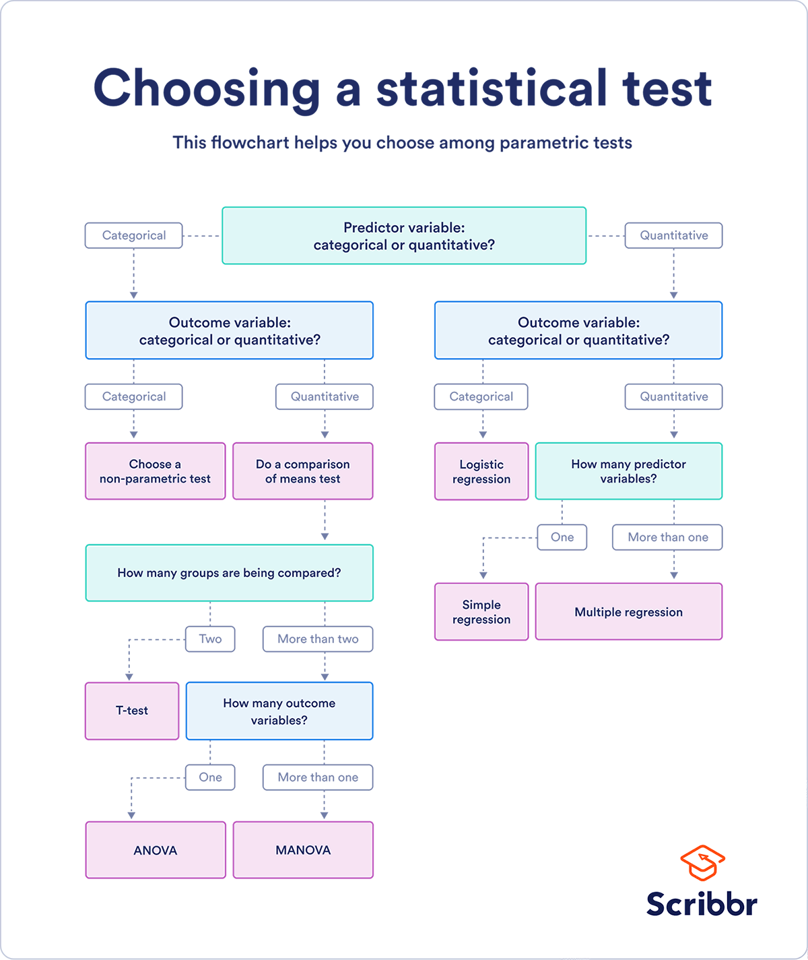Choose the test that fits the types of predictor and outcome variables you have collected (if you are doing an [experiment](https://www.scribbr.com/methodology/experimental-design/), these are the [independent and dependent variables](https://www.scribbr.com/methodology/independent-and-dependent-variables/)). Consult the tables below to see which test best matches your variables.

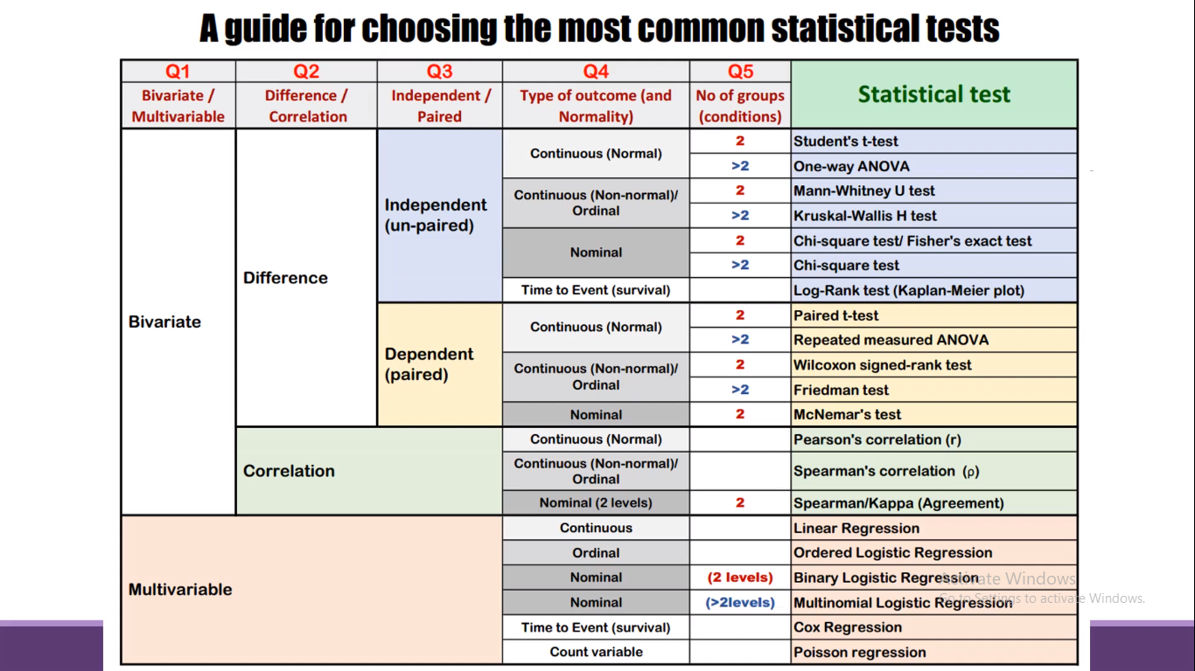

## HYPOTHESIS TESTING IN BUSINESS:

When it comes to data-driven decision-making, there’s a certain amount of risk that can mislead a professional. This could be due to flawed thinking or observations, [incomplete or inaccurate data](https://online.hbs.edu/blog/post/data-wrangling), or the presence of unknown variables. The danger in this is that, if major strategic decisions are made based on flawed insights, it can lead to wasted resources, missed opportunities, and catastrophic outcomes.

The real value of hypothesis testing in business is that it allows professionals to test their theories and assumptions before putting them into action. This essentially allows an organization to verify its analysis is correct before committing resources to implement a broader strategy.

As one example, consider a company that wishes to launch a new marketing campaign to revitalize sales during a slow period. Doing so could be an incredibly expensive endeavor, depending on the campaign’s size and complexity. The company, therefore, may wish to test the campaign on a smaller scale to understand how it will perform.

In this example, the hypothesis that’s being tested would fall along the lines of: “If the company launches a new marketing campaign, then it will translate into an increase in sales.” It may even be possible to quantify how much of a lift in sales the company expects to see from the effort. Pending the results of the pilot campaign, the business would then know whether it makes sense to roll it out more broadly.

## KEY CONSIDERATIONS FOR HYPOTHESIS TESTING

### **1. Alternative Hypothesis and Null Hypothesis**

In hypothesis testing, the hypothesis that’s being tested is known as the **alternative hypothesis**. Often, it’s expressed as a correlation or statistical relationship between variables. The **null hypothesis**, on the other hand, is a statement that’s meant to show there’s no statistical relationship between variables being tested. It’s typically the exact opposite of whatever is stated in the alternative hypothesis.

For example, consider a company’s leadership team who historically and reliably sees $12 million in monthly revenue. They want to understand if reducing the price of their services will attract more customers and, in turn, increase revenue.

In this case, the alternative hypothesis may take the form of a statement such as: “If we reduce the price of our flagship service by five percent, then we’ll see an increase in sales and realize revenues greater than $12 million in the next month.”

The null hypothesis, on the other hand, would indicate that revenues wouldn’t increase from the base of $12 million, or might even decrease.

### **2. Significance Level and P-Value**

Statistically speaking, if you were to run the same scenario 100 times, you’d likely receive somewhat different results each time. If you were to plot these results in a distribution plot, you’d see the most likely outcome is at the tallest point in the graph, with less likely outcomes falling to the right and left of that point.

KEY CONSIDERATIONS FOR HYPOTHESIS TESTING

1. Alternative Hypothesis and Null Hypothesis

In hypothesis testing, the hypothesis that’s being tested is known as the alternative hypothesis. Often, it’s expressed as a correlation or statistical relationship between variables. The null hypothesis, on the other hand, is a statement that’s meant to show there’s no statistical relationship between variables being tested. It’s typically the exact opposite of whatever is stated in the alternative hypothesis.

For example, consider a company’s leadership team who historically and reliably sees $12 million in monthly revenue. They want to understand if reducing the price of their services will attract more customers and, in turn, increase revenue.

In this case, the alternative hypothesis may take the form of a statement such as: “If we reduce the price of our flagship service by five percent, then we’ll see an increase in sales and realize revenues greater than $12 million in the next month.”

The null hypothesis, on the other hand, would indicate that revenues wouldn’t increase from the base of $12 million, or might even decrease.

2. Significance Level and P-Value

Statistically speaking, if you were to run the same scenario 100 times, you’d likely receive somewhat different results each time. If you were to plot these results in a distribution plot, you’d see the most likely outcome is at the tallest point in the graph, with less likely outcomes falling to the right and left of that point.

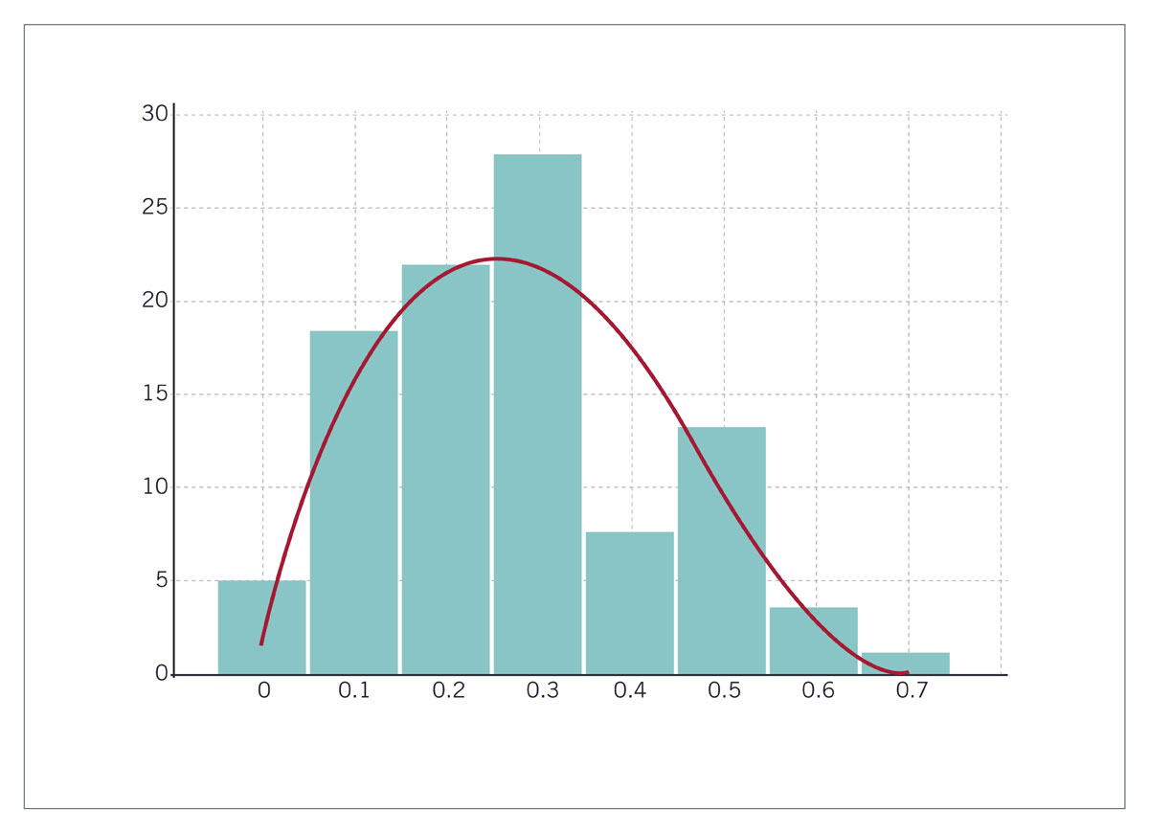

With this in mind, imagine you’ve completed your hypothesis test and have your results, which indicate there may be a correlation between the variables you were testing. To understand your results' significance, you’ll need to identify a p-value for the test, which helps note how confident you are in the test results.

In statistics, the p-value depicts the probability that, assuming the null hypothesis is correct, you might still observe results that are at least as extreme as the results of your hypothesis test. The smaller the p-value, the more likely the alternative hypothesis is correct, and the greater the significance of your results.

3. One-Sided vs. Two-Sided Testing

When it’s time to test your hypothesis, it’s important to leverage the correct testing method. The two most common hypothesis testing methods are one-sided and two-sided tests, or one-tailed and two-tailed tests, respectively.

Typically, you’d leverage a one-sided test when you have a strong conviction about the direction of change you expect to see due to your hypothesis test. You’d leverage a two-sided test when you’re less confident in the direction of change.

4. Sampling

To perform hypothesis testing in the first place, you need to collect a sample of data to be analyzed. Depending on the question you’re seeking to answer or investigate, you might collect samples through surveys, observational studies, or experiments.

A survey involves asking a series of questions to a random population sample and recording self-reported responses.

Observational studies involve a researcher observing a sample population and collecting data as it occurs naturally, without intervention.

Finally, an experiment involves dividing a sample into multiple groups, one of which acts as the control group. For each non-control group, the variable being studied is manipulated to determine how the data collected differs from that of the control group.

With this in mind, imagine you’ve completed your hypothesis test and have your results, which indicate there may be a correlation between the variables you were testing. To understand your results' significance, you’ll need to identify a p-value for the test, which helps note how confident you are in the test results.

In statistics, the **p-value** depicts the probability that, assuming the null hypothesis is correct, you might still observe results that are at least as extreme as the results of your hypothesis test. The smaller the p-value, the more likely the alternative hypothesis is correct, and the greater the **significance** of your results.

### **3. One-Sided vs. Two-Sided Testing**

When it’s time to test your hypothesis, it’s important to leverage the correct testing method. The two most common hypothesis testing methods are **one-sided** and **two-sided tests**, or one-tailed and two-tailed tests, respectively.

Typically, you’d leverage a one-sided test when you have a strong conviction about the direction of change you expect to see due to your hypothesis test. You’d leverage a two-sided test when you’re less confident in the direction of change.

### **4. Sampling**

To perform hypothesis testing in the first place, you need to collect a sample of data to be analyzed. Depending on the question you’re seeking to answer or investigate, you might collect samples through surveys, observational studies, or experiments.

A **survey** involves asking a series of questions to a random population sample and recording self-reported responses.

**Observational studies** involve a researcher observing a sample population and collecting data as it occurs naturally, without intervention.

Finally, an **experiment** involves dividing a sample into multiple groups, one of which acts as the control group. For each non-control group, the variable being studied is manipulated to determine how the data collected differs from that of the control group.